# ABC Inc.

**Five new employees; Beatrice, Paul, Smith, Felix, Franklin as users was created**

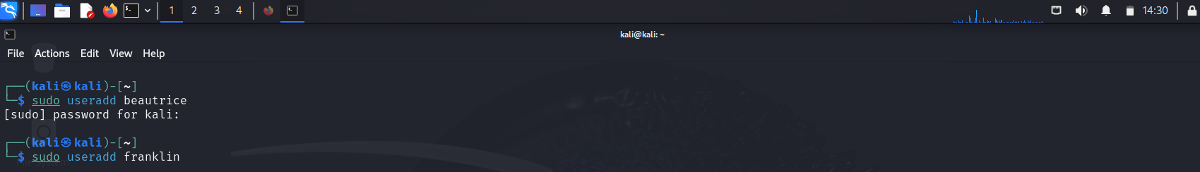





**Then two groups were created; Finance and IT Deartment**



**User Felix and Franklin are added to the IT group**



**While user Paul and Smith are added to Finance group**



**An encrypted file is created with the message ‘this is a confidential file which means it on a need to know basis’ which the encryption is an AES symmetric encryption done with openssl**



**And the encrypted file is displayed as:**



**The User, group and other are given read and write permissions on the file**



**Using set file access control list Finance group is given read access**

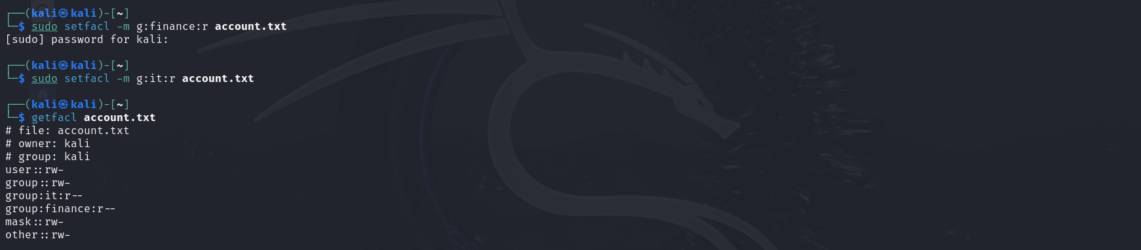

**While user Beatrice and IT group is given read and write permission on the file**

